Sony ICF-2010 Q303 FET protection
The picture below shows the location of Q303 and the voltages on the various terminals when the radio is tuned to the AM, FM and AIR bands. The important voltages are the AM voltages, shown in red without parenthesis. If the drain voltage is around 1.2-1.8V (nominally 2.9V), you have a leaky gate (in such a case, the gate voltage would also be around these values). In case of an open device, the drain would sit near 4.5V or the +ve power supply rail, as no current would flow through it. The other 2 voltages shown in square and angled brackets in the figure below are when the FM and AIR bands are selected, respectively. The Sony FAQ suggests using MPF-102 (Radio Shack) or other similar N type high-frequency FET.
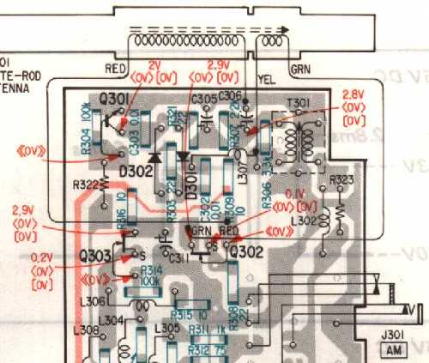
To get rid of the problem for good, one can put some high frequency diodes to limit the ESD at the antenna input such as shown below. This mimics the protection that is there when the internal whip antenna is connected to the RF front stage, which gets bypassed when the external antenna is connected. Using power diodes or other low frequency diodes could hurt the RF performance.
